MyMatrix,-1,MATRIX,

HELPPOPUPID (8210)

ALLOW MULTIPLE CONSTRAINT REFERENCES

AUTO LIST(KCEX(Title)):

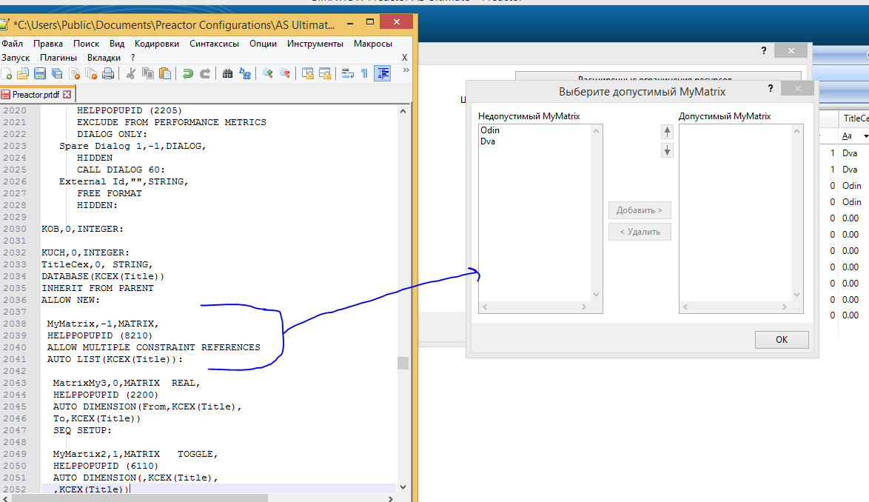

MyMatrix3,0,MATRIX REAL,

AUTO DIMENSION(From,KCEX(Title),

To,KCEX(Title))

SEQ SETUP:

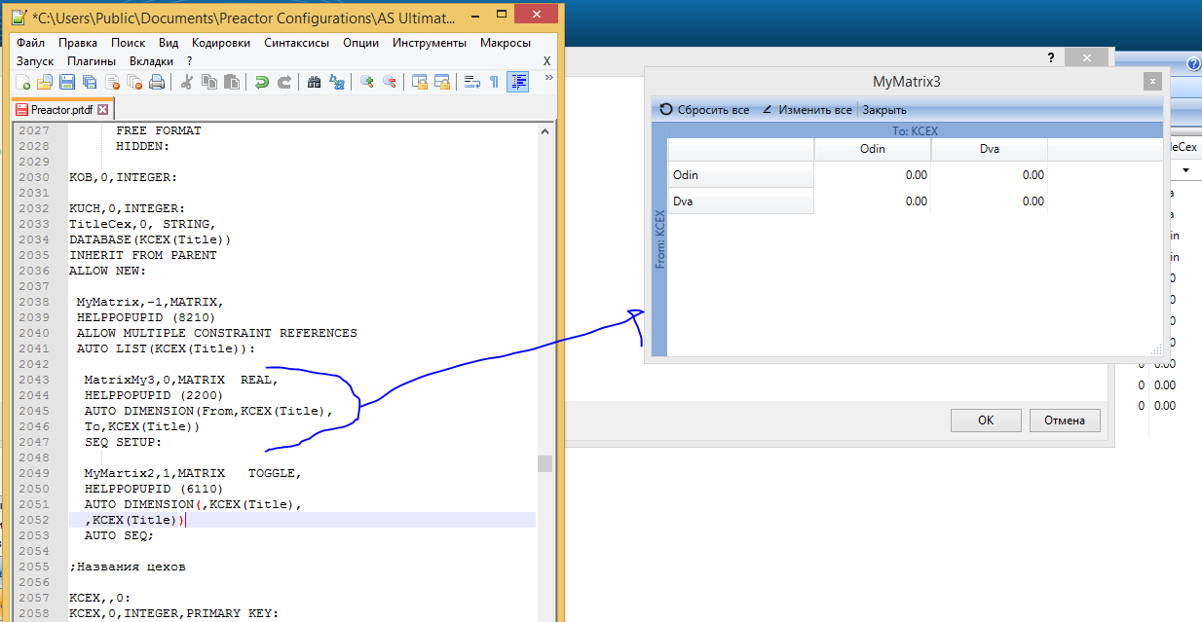

MyMartix2,1,MATRIX TOGGLE,

HELPPOPUPID (6110)

AUTO DIMENSION(,KCEX(Title),

,KCEX(Title))

AUTO SEQ;

